Guru Nanak Dev Engineering College Ludhiana

Department of Information Technology

Web Technology

Fourth Semester

Session: January – June 2021

Batch: 2019 – 2023



Submitted to: Er. Hanit Kaur Submitted by: Mayank Mishra

Department of Information Technology URN:1905234

Assistant Professor CRN:1921145

D2ITB3

1. Create a simple web pages by writing HTML using a simple text editor, notepad. Demonstrate the following components of the web page: Page title and headings Paragraph and inline images

<!DOCTYPE html>

<html lang="en">

<head>

    <meta charset="UTF-8">

    <meta http-equiv="X-UA-Compatible" content="IE=edge">

    <meta name="viewport" content="width=device-width, initial-scale=1.0">

    <title>Guru Nanak Dev Engineering College</title>

</head>

<body>

    <h1>Information Technology</h1>

        <p>IT governance: This refers to the combination of policies and processes that ensure IT systems are effectively run and in alignment with the organization’s needs. IT operations: This is a catchall category for the daily work of an IT department. This includes providing tech support, network maintenance, security testing and device management duties. Hardware and infrastructure: This focus area refers to all the physical components of IT infrastructure. This pillar of IT includes the setup and maintenance of equipment like routers, servers, phone systems and individual devices like laptops.</p>

         <h2>Guru Nanak Dev Engineering College Logo</h2>

         <img src="https://www.logolynx.com/images/logolynx/9f/9f2c4042d28462d69f738e6018bb4ff9.jpeg" alt="GNDEC Logo" srcset="" width = "300 px  height= "350 px">

</body>

</html>

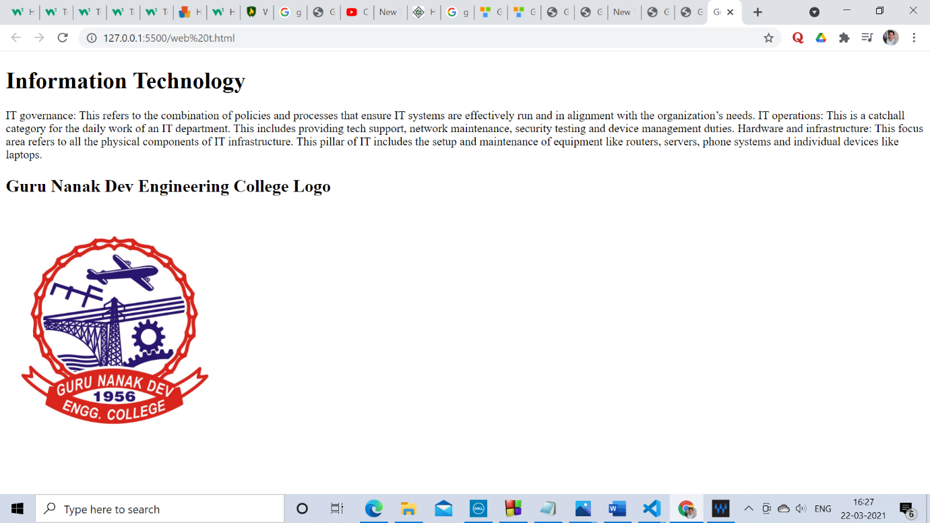

2. Demonstrate the use of links, lists, and tables in html. You should be able to link separate pages and create named links within a document, using them to build a “table of contents”.

<!DOCTYPE html>

<html>

    <head>

        <style>

            *p{

                background-color: rgb(172, 109, 27);

            }

            table,th,td{

                border:1px solid black;

                border-collapse:collapse;

            }

            th,td{

                padding:15px;

                text-align:left;

            }

        </style>

    </head>

    <body>

        <h1>HTML Links</h1>

        <p><a href="https://www.w3schools.com/">Visit W3schools.com</a>

        </p>

        <h2> Book List</h2>

        <ul>

            <li>Three man in a boat</li>

            <li>Invisible Man</li>

            <li>Gita</li>

        </ul>

        <table style = "Width:100%">

         <tr>

             <th>FirstName</th>

            <th>LastName</th>

            <th>Age</th>

            </tr>

            <tr>

                <td>DR.Manmohan</td>

                 <td>Singh</td>

                 <td>80</td>

            </tr>

            <tr>

                <td>Narendra</td>

                <td>Modi</td>

                <td>60</td>

            </tr>

        </table>

        <p>Good Boy</p>

        <script src = 'mayank.js'></script>

    </body>

</html>

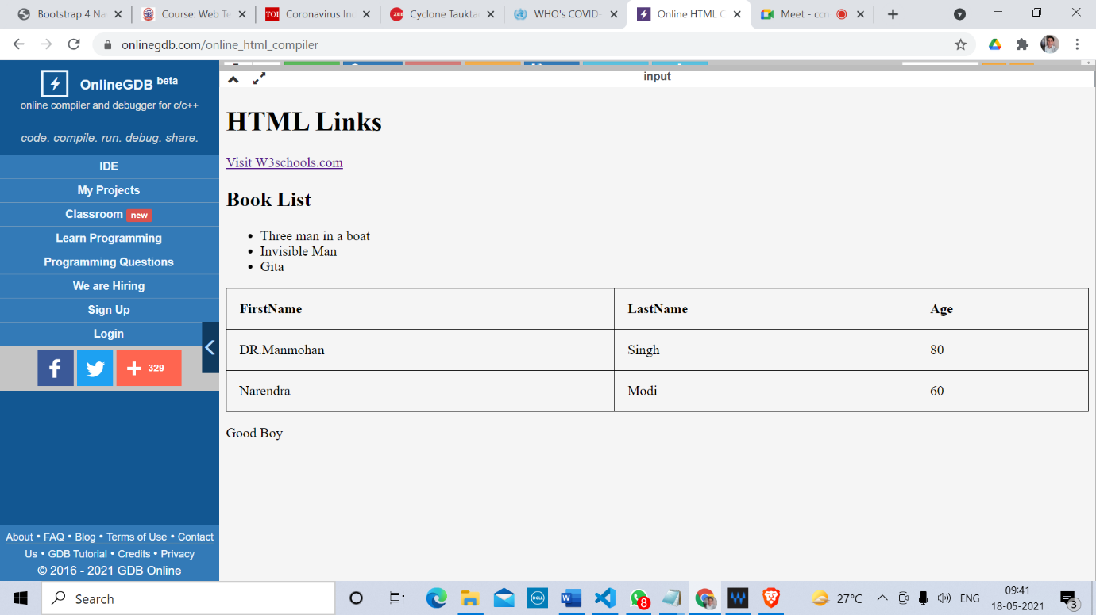

3 Create a simple forms in HTML and demonstrate the use of various form elements like input box, textarea, submit and radio buttons etc.<!

DOCTYPE html>

<html>

    <head>

        <style>

            input{

            background-color:rgb(38, 148, 192);

            border:2px solid rgb(73, 110, 134);

            border_radius:4px;

            }

            textarea{

                background-color:rgb(235, 219, 225);

            }

            select{

                background-color:blueviolet;

            }

            input[type = submit]

            {

                background-color:aquamarine;

                padding:16px 32px;

                margin:4px 2px;

                border:2px;

                color:beige;

            }

            h1{

                font-size:x-large;

                font-weight: 300;

                color: brown;

            }

            p{

                font-size: medium;

                font-family: Verdana, Geneva, Tahoma, sans-serif;

                color: rgb(197, 24, 82);

            }

        </style>

    </head>

    <body>

        <h1>Welcome, Explore my Website</h2>

        <p> Hope you will enjoy here.</p>

        <form action ="/action_page.php">

            <label for="fname">First name:</label><br>

            <input type="text" id="fname" name="fname" value="Your First  Name"><br>

            <label for="lname">Last name:</label><br>

            <input type="text" id="lname" name="lname" value="Your Last Name"><br><br>

            <label for="gmail">G-mail Id:</label><br>

            <input type="text" id="gmail" name="gmail" value="@gmail.com"><br>

        <input type = "radio" id= "male" name = "gender" value = "male">

        <label for= "male" >Male </label><br>

        <input type = "radio" id= "female" name = "gender" value = "female">

        <label for= "female" >Female </label><br>

        <input type = "radio" id= "other" name = "gender" value = "other">

        <label for= "other" >other</label><br>

        <input type="checkbox" id="vehicle1" name="vehicle1" value="Bike">

  <label for="vehicle1"> I have a bike</label><br>

  <input type="checkbox" id="vehicle2" name="vehicle2" value="Car">

  <label for="vehicle2"> I have a car</label><br>

  <input type="checkbox" id="vehicle3" name="vehicle3" value="Boat">

  <label for="vehicle3"> I have a boat</label><br><br>

        <textarea name = "message" rows="10" cols="30">Kindly Write your suggestion! </textarea>

        <input type="submit" value="Submit">

        </form>

    </body>

</html>

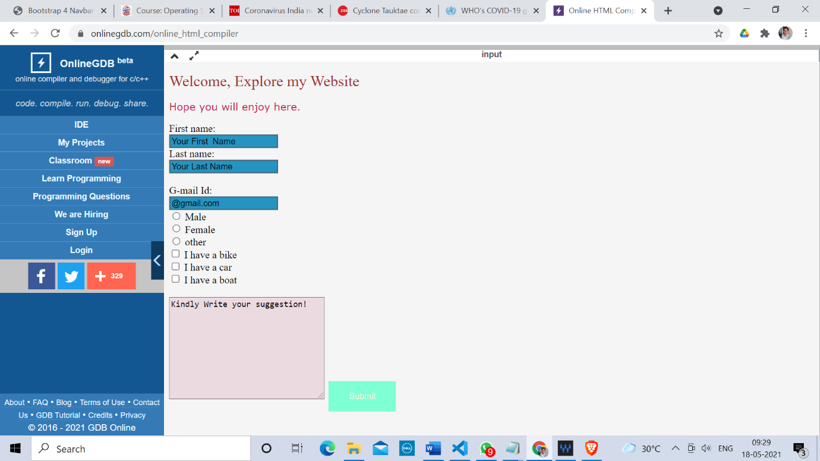

4. Demonstrate the use of cascading style sheets(CSS) (inline, internal and external) to specify various aspects of style, such as colours and text fonts and sizes, in html document.

html>

<head>

<style>

body {

  background-color: #fc9; /* same as #ffcc99 */

}

h1 {<!DOCTYPE html>

  color: #f0f; /* same as #ff00ff */

}

p {

    font-family: "Times New Roman", Times, serif;

  color: #b58; /* same as #bb5588 */

  font-size: 2em;

}

</style>

</head>

<body>

<h1>Keep visiting </h1>

<p>We are happy to help you.</p>

</body>

</html>

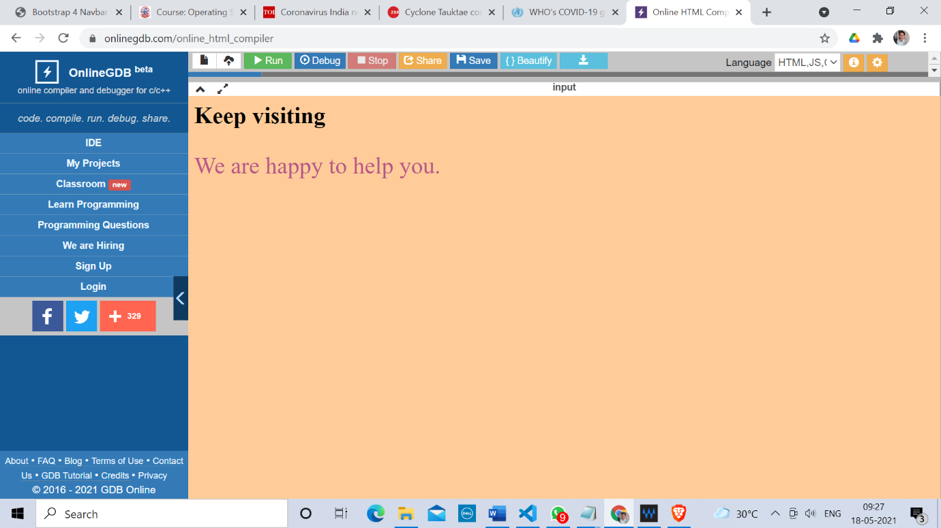

5. Creation of web pages using HTML5 and CSS3

<!DOCTYPE html>

<html lang="en">

<head>

<title>CSS Template</title>

<meta charset="utf-8">

<meta name="viewport" content="width=device-width, initial-scale=1">

<style>

* {

box-sizing: border-box;

font-family: Arial, Helvetica, sans-serif;

}

body {

margin: 0;

font-family: Arial, Helvetica, sans-serif;

}

/* Style the top navigation bar */

.topnav {

overflow: hidden;

background-color: #333;

}

/* Style the topnav links */

.topnav a {

float: left;

display: block;

color: #f2f2f2;

text-align: center;

padding: 14px 16px;

text-decoration: none;

}

/* Change color on hover */

.topnav a:hover {

background-color: #ddd;

color: black;

}

/* Style the content */

.content {

background-color: #ddd;

padding: 10px;

height: 200px; /* Should be removed. Only for demonstration */

}

/* Style the footer */

.footer {

background-color: #f1f1f1;

padding: 10px;

}

</style>

</head>

<body>

<div class="topnav">

<a href="#">Link</a>

<a href="#">Link</a>

<a href="#">Link</a>

</div>

<div class="content">

<h2>Welcome to India</h2>

<p>Explore</p>

</div>

<div class="footer">

<p>Footer</p>

</div>

<svg width="300" height="200">

<polygon points="100,10 40,198 190,78 10,78 160,198"

style="fill:lime;stroke:purple;stroke-width:5;fill-rule:evenodd;" />

Sorry, your browser does not support inline SVG.

</svg>

</body>

</html>

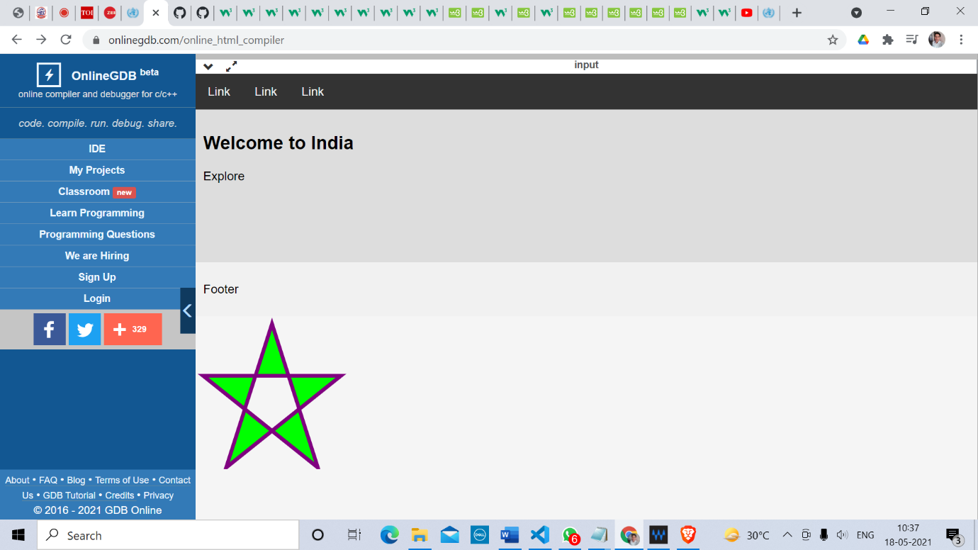

6. Demonstrate the use of bootstrap framework

<!DOCTYPE html>

<html lang="en">

<head>

<meta charset="utf-8">

<meta name="viewport" content="width=device-width, initial-scale=1, shrink-to-fit=no">

<title>Bootstrap 4 Navbar Fixed to Top</title>

<link rel="stylesheet" href="https://stackpath.bootstrapcdn.com/bootstrap/4.5.2/css/bootstrap.min.css">

<link rel="stylesheet" href="https://maxcdn.bootstrapcdn.com/font-awesome/4.7.0/css/font-awesome.min.css">

<script src="https://code.jquery.com/jquery-3.5.1.min.js"></script>

<script src="https://cdn.jsdelivr.net/npm/popper.js@1.16.1/dist/umd/popper.min.js"></script>

<script src="https://stackpath.bootstrapcdn.com/bootstrap/4.5.2/js/bootstrap.min.js"></script>

<style>

.bs-example{

margin: 20px;

}

body{

padding-top: 70px;

}

</style>

</head>

<body>

<div class="bs-example">

<nav class="navbar navbar-expand-md navbar-dark bg-dark fixed-top">

<a href="#" class="navbar-brand">Brand</a>

<button type="button" class="navbar-toggler" data-toggle="collapse" data-target="#navbarCollapse">

<span class="navbar-toggler-icon"></span>

</button>

<div class="collapse navbar-collapse" id="navbarCollapse">

<div class="navbar-nav">

<a href="#" class="nav-item nav-link active">Home</a>

<a href="#" class="nav-item nav-link">Profile</a>

<a href="#" class="nav-item nav-link">Messages</a>

<a href="#" class="nav-item nav-link disabled" tabindex="-1">Reports</a>

</div>

<div class="navbar-nav ml-auto">

<a href="#" class="nav-item nav-link">Login</a>

</div>

</div>

</nav>

<!-- Demo Content -->

<div class="container">

<div class="jumbotron">

<h1>Have a look over my content</h1>

<p class="lead">The fixed-top navbar bar is fixed at the top of the viewport and does not scroll with the rest of the page.</p>

</div>

<p>Readiness

To help policy-makers and planners invest in ensuring the readiness, education and learning of the health workforce, WHO provides support for strategic workforce planning, support and capacity-building.

Interim guidance on Health workforce policy and management in the context of the COVID-19 pandemic response

Health Workforce Estimator (HWFE) to anticipate response staffing requirements

The Health Workforce Support and Safeguards List comprises countries facing the most pressing health workforce challenges, from which active international recruitment is discouraged.

Dedicated learning resources to support expanded clinical roles and tasks, as well as support for COVID-19 vaccines roll-out, are available for individual health workers. Managers and planners can access additional resources to support learning and education requirements.

OpenWHO has a multi-language course library that is also accessible through the WHO Academy COVID-19 learning app, which includes a new augmented reality course on personal protective equipment.

The COVID-19 vaccine introduction toolbox has the latest resources, including guidance, tools and trainings.

Learn how to utilise your role as a health worker and trusted source of information. You can also be a role model by getting the vaccine, protecting yourself and helping your patients and the public understand the benefits.

Review WHO Information Network for Epidemics (EPI-WIN) updates for accurate information and clear explanations about COVID-19 and vaccines.

Access the community engagement guide for tips and discussion topics to be considered in vaccine delivery and demand.

Learn about infodemic management: help your patients and communities manage the overabundance of information and learn how to seek trusted sources.

Infection prevention and control

Preventing SARS-CoV-2 infections in health workers requires a multi-pronged, integrated approach of infection prevention and control (IPC) and occupational health and safety (OHS) measures.

WHO recommends that all healthcare facilities establish and implement IPC programmes and OHS programmes with protocols that ensure health worker safety and prevent infections with SARS-CoV-2 in the work environment.

A blame-free system for managing health worker exposures to COVID-19 should be in place to promote and support reporting of exposures or symptoms. Health workers should be encouraged to report both occupational and non-occupational exposures to COVID-19..</p>

<p>Fusce enim arcu, interdum vel metus dignissim, venenatis feugiat purus. Nulla posuere orci ut leo sodales, sed cursus dolor ornare. Cum sociis natoque penatibus et magnis dis parturient montes, nascetur ridiculus mus. Etiam sit amet quam orci. Nulla sollicitudin lectus eget posuere venenatis. Sed vestibulum elementum sagittis. Quisque tristique tortor quis feugiat sollicitudin. Ut pellentesque luctus vulputate. Ut at odio ac erat blandit vehicula ut eget urna. In hac habitasse platea dictumst. Nullam ut iaculis nibh, eget eleifend elit.</p>

</div>

</div>

</body>

</html>

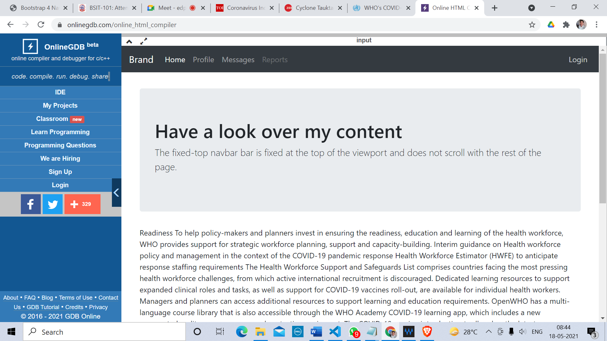

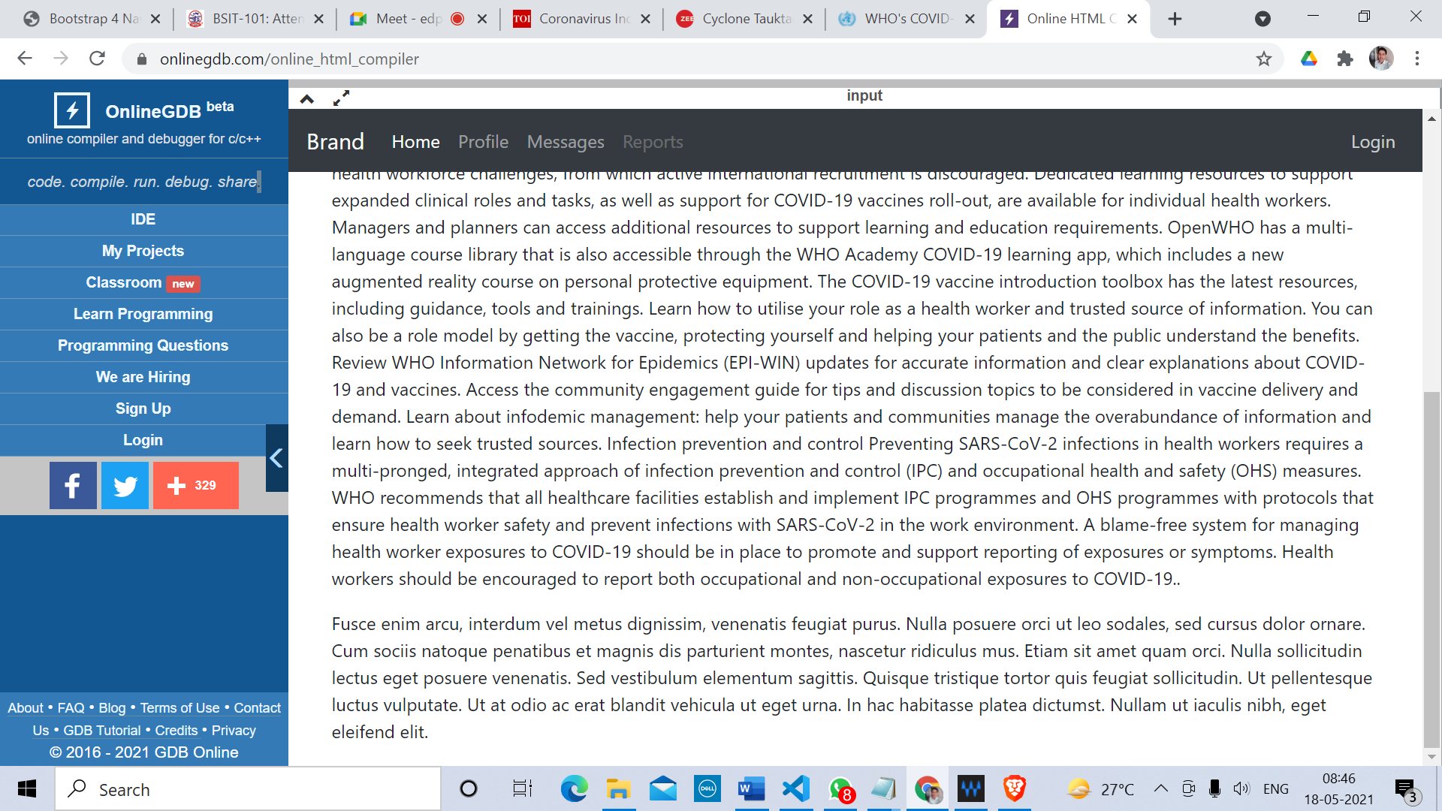

7. Creating a web page using PHP

<!DOCTYPE HTML>    
<html>  
<head>  
</head>  
<body>    
  
<?php  
// define variables and set to empty values  
$name = $email = $gender = $comment = $website = "";  
  
if ($_SERVER["REQUEST_METHOD"] == "POST") {  
  $name = test_input($_POST["name"]);  
  $email = test_input($_POST["email"]);  
  $website = test_input($_POST["website"]);  
  $comment = test_input($_POST["comment"]);  
  $gender = test_input($_POST["gender"]);  
}  
  
function test_input($data) {  
  $data = trim($data);  
  $data = stripslashes($data);  
  $data = htmlspecialchars($data);  
  return $data;  
}  
?>  
  
<h2>PHP Form Validation Example</h2>  
<form method="post" action="<?php echo htmlspecialchars($_SERVER["PHP_SELF"]);?>">    
  Name: <input type="text" name="name">  
  <br><br>  
  E-mail: <input type="text" name="email">  
  <br><br>  
  Website: <input type="text" name="website">  
  <br><br>  
  Comment: <textarea name="comment" rows="5" cols="40"></textarea>  
  <br><br>  
  Gender:  
  <input type="radio" name="gender" value="female">Female  
  <input type="radio" name="gender" value="male">Male  
  <input type="radio" name="gender" value="other">Other  
  <br><br>  
  <input type="submit" name="submit" value="Submit">    
</form>  
  
<?php  
echo "<h2>Your Input:</h2>";  
echo $name;  
echo "<br>";  
echo $email;  
echo "<br>";  
echo $website;  
echo "<br>";  
echo $comment;  
echo "<br>";  
echo $gender;  
?>  
  
</body>  
</html>

